**Information**

|  |  |  |
| --- | --- | --- |
| **CRIM ID** | **Title** | **Workstream** |
| C0459 | Service Delivery Overview Lobby – v0.1 | Service Management |

**Revision History**

|  |  |  |  |
| --- | --- | --- | --- |
| **Revision** | **Date** | **By** | **Remarks** |
| 0.1 | 08/01/2021 | Erika Sukevic | Base spec |
| 1.0 | 24/02/2021 | Erika Sukevic | Updates |
|  |  |  |  |
|  |  |  |  |

# CRIM Narrative

We need a new lobby called “Service Delivery Overview” which would have 4 lobby elements:

* Open jobs
* Overdue WOs
* % completed tasks within SLA
* WO about to breach the SLA
* Completed Deinstalls
* Completed Installs
* Completed Change Requests
* Materials dependent: ready to assign
* Materials dependent: ready to transfer

The filter of the lobby should have default on contract type = MS

All tiles and charts need to be clickable and bring Prepare Work Order screen.

### Open jobs

We need a tile which would count all open work tasks. Logic should bring records where work task status = New, Under Preparation, Prepared, Released, Work Started.

### Overdue WOs

We need a tile which would count all work tasks where Tunstall SLA date < sysdate.

Tile should only bring work tasks in the following statuses: New, Under Preparation, Prepared, Released, Work Started.

### % completed tasks within SLA

We need a pie chart which will show the % of the work tasks completed within SLA and the ones which are completed outside SLA. If possible, when user put the cursor on the pie chart it should show the count of the work tasks.

The logic should check the Actual Finish date of the task and compare it with the Tunstall SLA. If Tunstall SLA > Actual Finish then bring as within SLA; If Tunstall SLA < Actual Finish then bring as failed SLA.

### WO about to breach the SLA

We need a tile which will count the number of the work tasks about to breach the SLA. The logic should check the Tunstall SLA field and if the sysdate is within 24h of the SLA date then bring these tasks to the lobby. For example, if today is 08/01/21 and Tunstall SLA shows 09/01/21 the task should appear on the lobby. If today is 08/01/21 and Tunstall SLA is 12/01/21 then lobby should ignore this record.

Tiles should only bring work tasks in the following statuses: New, Under Preparation, Prepared, Released, Work Started.

### Completed Deinstalls

We need a lobby which would bring all work orders where work type = TCD or THD and status of the work order = WorkDone or Reported.

### Completed Installs

We need a lobby which would bring all work orders where work type = TCI_URGENT, TCI_NON_URGENT, THI_URGENT or THI_NON_URGENT and status of the work order = WorkDone or Reported.

### Completed Change Requests

We need a lobby which would bring all work orders where work type = TCR or THCR and status of the work order = WorkDone or Reported.

### Materials Dependent: Ready to Assign

We need a tile which would count all unassigned work orders where all material requisition lines associated to the work task are reserved. The material requisition must exist for task to appear on this lobby.

To identify unassigned check Work Assignments tab – it should not have records against it.

Then check the Materials tab. Bring the task to the lobby when all material lines are reserved – where qty required = qty reserved.

### Materials Dependent: Ready to Transfer

We need a lobby tile which would show the count of the assigned but not transferred work tasks which has material requisition attached to it with the transport task in status Picked or Executed.

Work task should have work assignment attached to it, but Sent Date should be blank.

The material requisition which attached to the work task should have associated transport task(s) in status picked or executed.

# Design Q&A

# BA/Developer Notes/ Related CRIM

# Technical Proposal

*\*\*\*\* Guidance Notes – Remove prior to submission \*\*\*\**

***********************************************

# Technical Solution

## Technical Process

**Lobby Page:**

Service Delivery Overview

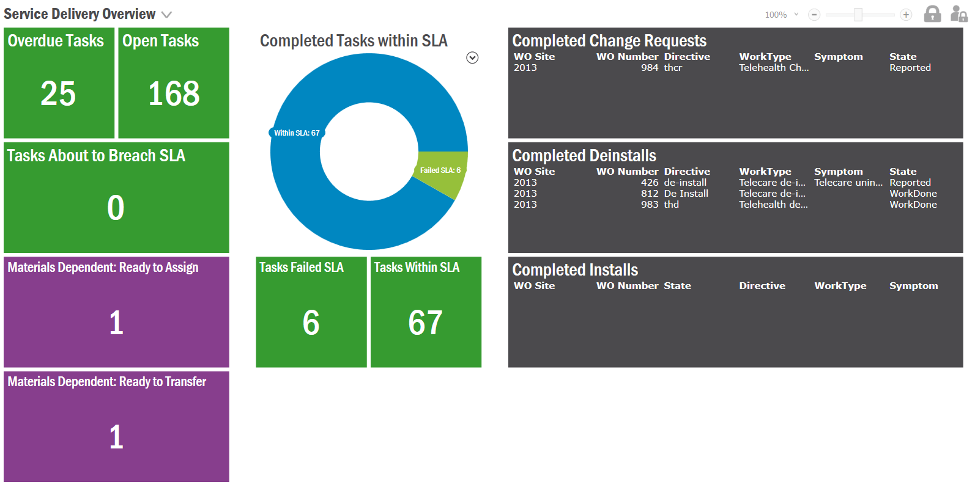

Pre-requisites: Deploy the IAL objects following the steps mentioned under deployment instructions section

***********************************************

## Report Components

********************************************

## Known Dependencies

*\*\*\*\* Guidance Notes – Remove prior to submission \*\*\*\**

***********************************************

# Deployment Instructions

Deploy Following IAL objects to the environment. Files are located at the Deliverables Folder (Tunstall Deliverables\EA_SERVICES\IAL OBJECTS)

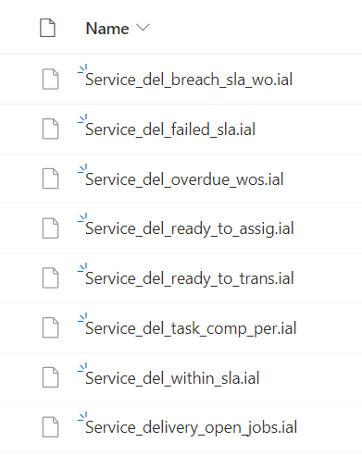

Steps:

1. Go to IAL Object Developer Window

Solution Manager/ Business Reporting & Analysis/ Information Access Layer / IAL Object Developer

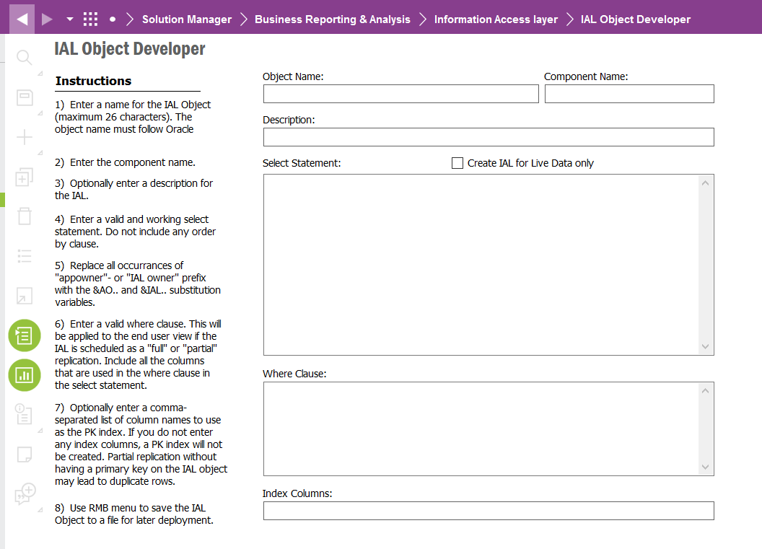

1. RMB -> Load from file…

Select the IAL object from the location mentioned above ( 1 file at a time)

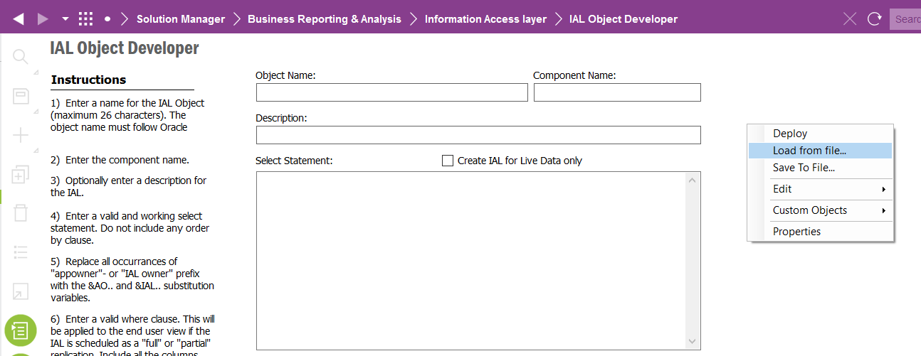

1. RMB -> Deploy

Deploy the IAL object to the database

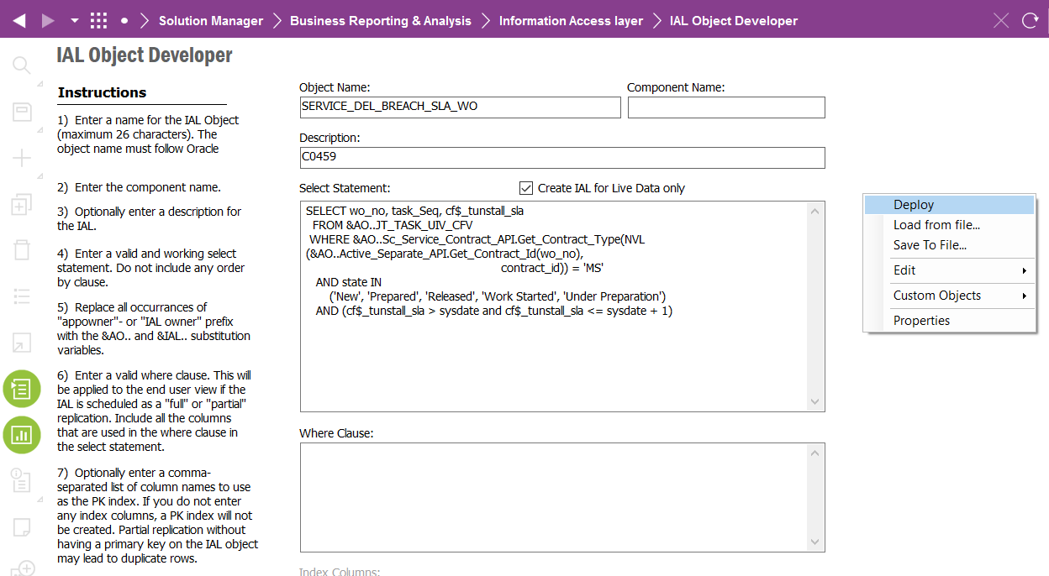

This operation will deploy the IAL object as views in the database

1. Grant permission to the IAL objects

As with any other database object IAL objects required to be granted to permission sets. Grant the IAL objects to the permission set used by the lobby page

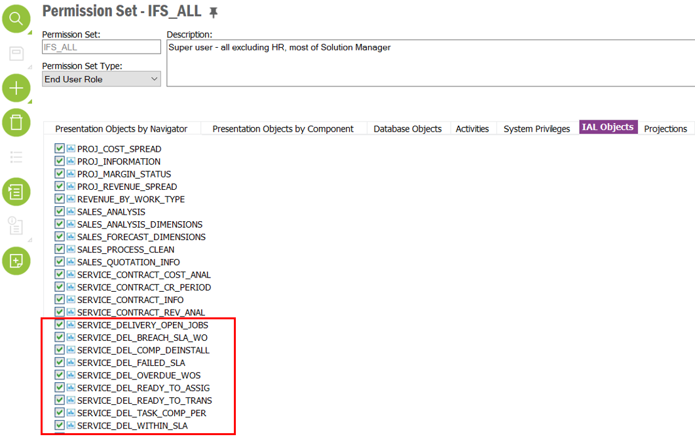

1. Import lobby page

Import lobby page - Service Delivery Overview- found in Tunstall Deliverables\EA_SERVICES\LOBBY using the ‘Import Page’ command in Lobby Overview window

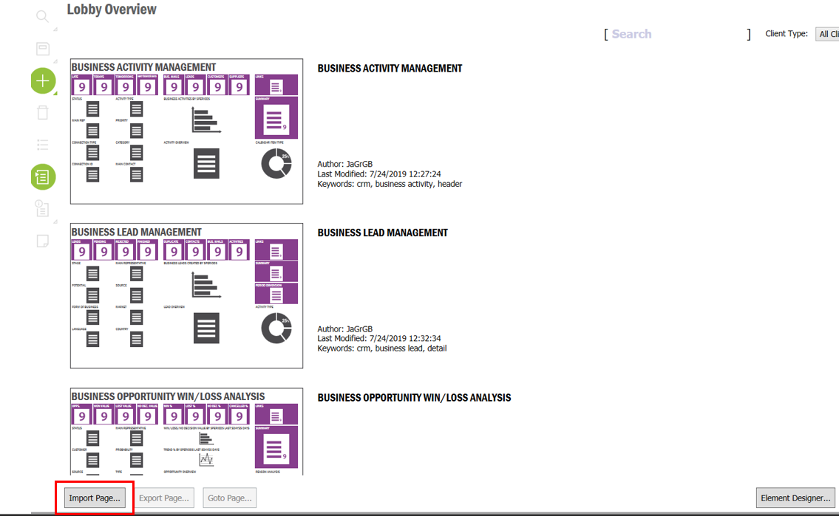

1. Grant permission to the lobby page
2. Locate lobby page in the Lobby Overview window
3. RMB -> Edit

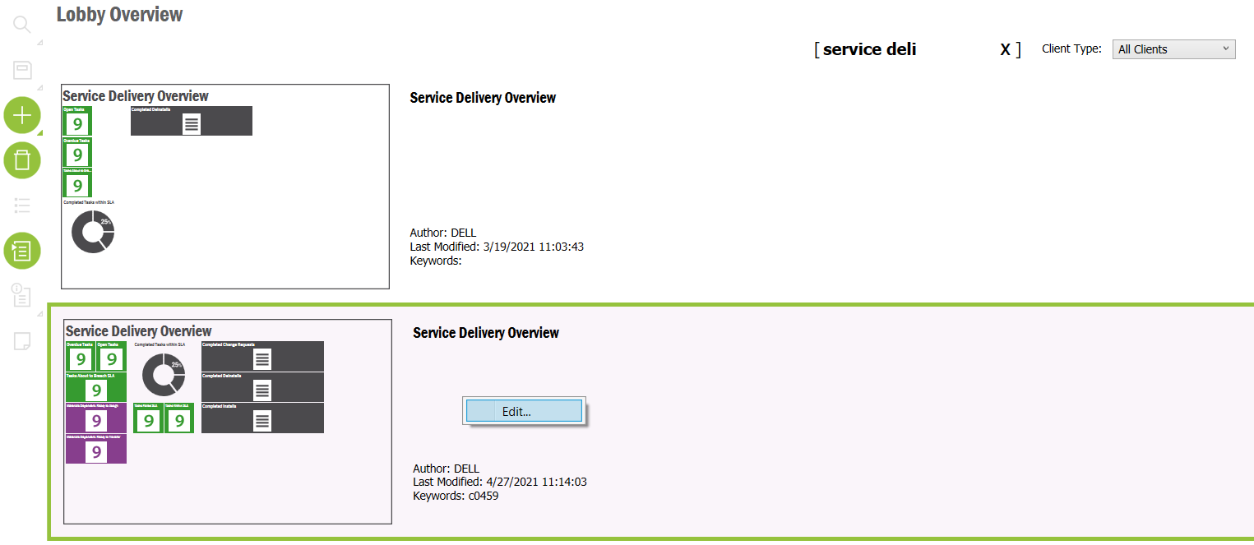

1. Click on the Presentation Object link

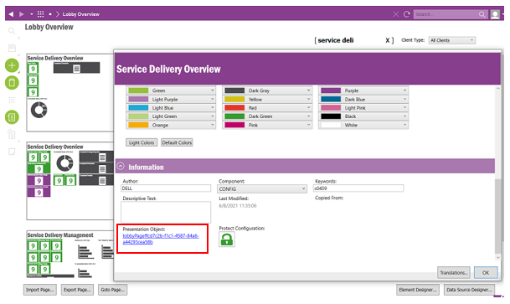

1. Grant permission to the indented permission set

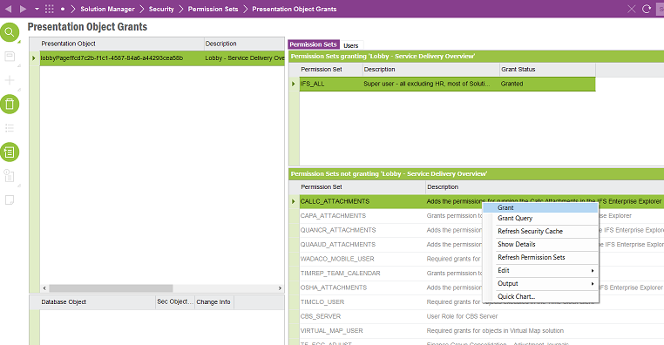

# Developer Test Proposal

*\*\*\*\* Guidance Notes – Remove prior to submission \*\*\*\**

* *Tests recommended by the developer to be included in UAT*

*e.g.*

| **Test ID** | **Recommended Test** |
| --- | --- |
| 1 | Test the boundaries of all parameters |
| 2 |  |
| 3 |  |
| 4 |  |
| 5 |  |
| 6 |  |
| 7 |  |

***********************************************

# User Acceptance Tests

***********************************************